

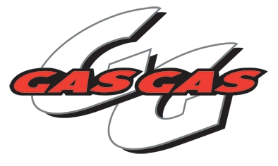

Sunday 12th November saw the first round of the Gas Gas Sponsored Winter Series. With the Race time brought forward by 30-miuntues to ensure all riders could arrive back in time to pay respect to past and present armed forces men and women who have given the lives. The 260-adult riders all lined up at the raise of the white flag to impeccably observe the two-minutes.

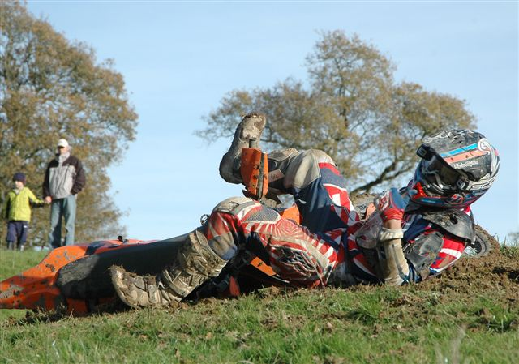
A man with a sense of humour!!!

It was always going to be difficult to top the excellent racing at Maiden Newton but it seemed again that Mike (now out of plaster and pumped up for revenge on the 10-year old that nailed him in the kids race at Two-valleys) had pulled another great track from the bag.

The track location, which was just outside of Ticelton near Dorchester, had taken a lot of rain on the Thursday and Friday prior to the race, so a tractor and Plan B parking were on hand just in case.

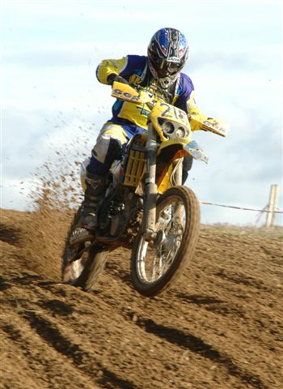

The track started with a short sprint into a sweeping left hand turn that lead into twisty Moto-X section, before the riders entered through a gate and down a steep grassy hill that in turn lead to the cattle grazing area, that was not just mud guys if you get my drift, for those of you that followed a four banger through there and you got a mouthful - chances are your talking bullsh*t.

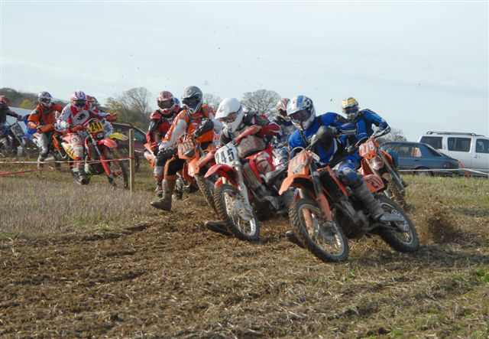
Clubman 4-bangers take the first bend

Then the first of the woods, lets not here the “stubble field racing“ for this one please. Exiting the woods the riders were confronted by the start of sandy 4X4 challenge section that was awash with affluent mothers driving 500 metres on the school run!!!! The jumps looked inviting as you raced towards them, and then flying over them only to find they had nothing behind them, many of the bikes landed Somerset, or the riders just got spat - just ask club man 2-stroke Andy Burgess, who still has problems with his ribs now.

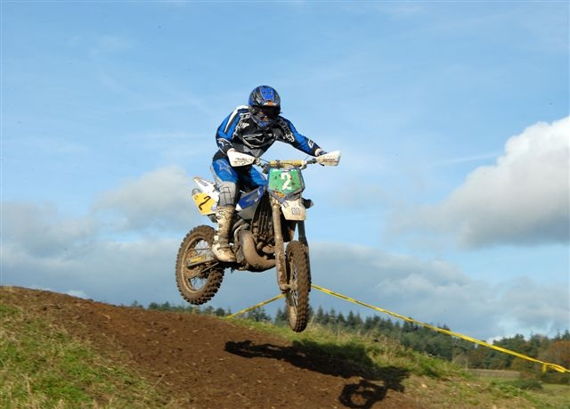
James Jackman showing us how it should be done

With over half the track running through woods it was going to be a tough and tiring race that saw little passing opportunities within the woods. The track quickly formed deep but firm ruts and berms through many of the twist and turns.

In the championship class newly promoted Mark (he’s a lumberjack and he’s OK) Cornick and Jeff “Gossey” Goss lined up amongst the really fast boys. As the flag dropped at 11.02 it was Matt Ridgeway that took the holeshot and lead for the whole race.

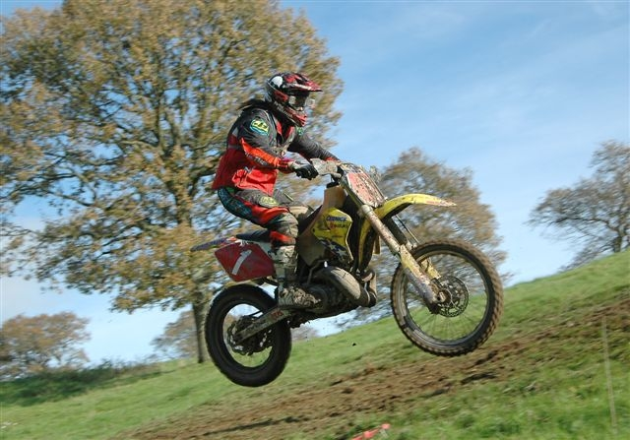
Gossy lookin’ very stylish and at least the bike started this race!!!

Mark Cornick, who onboard the new 450 KTM, seemed to struggle off the line, though ever the sportsman he stopped to pick up an injured Bradley King, before then stopping at the end of the first lap as he’d forgotten to secure the original lap counter tag to his bike not your day then Mark!!!

Mark Ridgeway, who passed most people as if they were going backwards, was the first across the line 2-minutes a head of the summer series winner John Hayman with Gary Baker in third all on twelve laps.

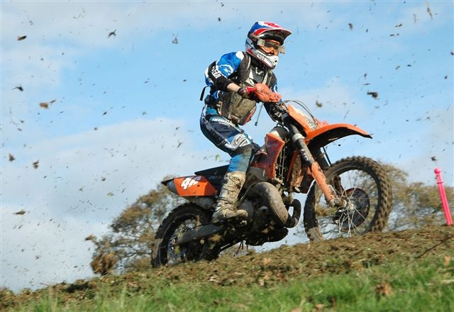
Overall winner Matt Ridgeway on board what looks like a Flymo???

In the experts over 40’s quick starting Jerry “Attack” Howell took the holeshot, but it was Ian Proudfoot (The Michael Schumacher of the over 40’s) took top spot again, with newly listed Michael Brookes in second and with Jerry in third all on 11 laps.
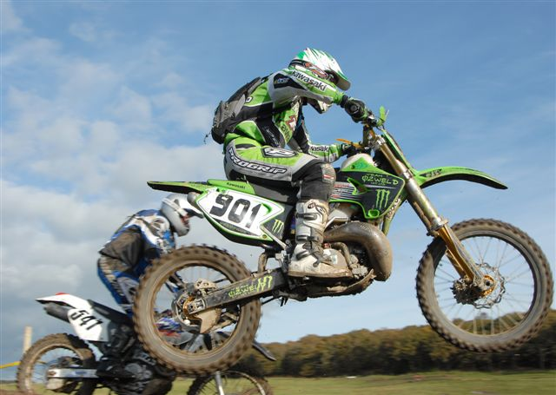
Jerry, doesn’t matter what time the race starts, my bike will be first to be scrutineered Howell

In the experts the Armstrong family Brad and Dad Paul who have recently formed the Family Armstrong Race Team, saw Brad take a huge lead through the first field before dropping the mean green machine allowing Jon Himan through. Dad, who originally from Transylvania, tried to impale himself on stake on the last lap. and just limped home. It was Jon Hinman who crossed the line first with staggering 10-minute lead over second place Nigel Wyckam and Brad Armstrong third - all on 11-laps. Four place man Euan Harrison has been advised to keep his own championship results as primary School numerously teacher Sue can’t add up. Sorry Euan

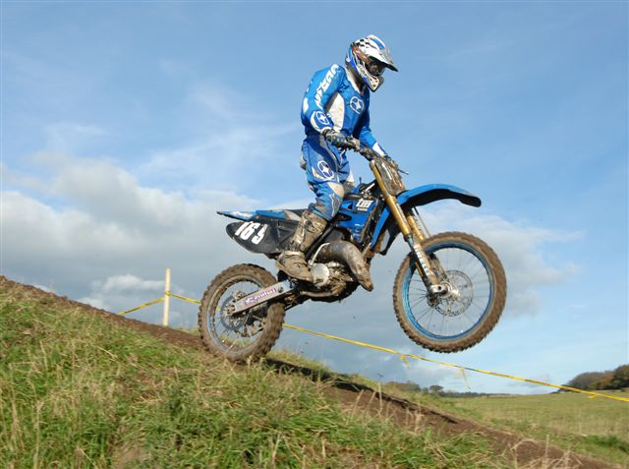
A TM in Motion now that’s rare!!!
In the clubman 2-stroke Tim Cotton took the top honours with 20-seconds over newly promoted Richard Wiltshire with Darren Hounsell in third - all on 10-laps.

In the clubman 4-Stroke Adam Senior had the smallest of margins of 3-seconds over Tom Pauley in second with Steven Bird in third - all on ten laps.

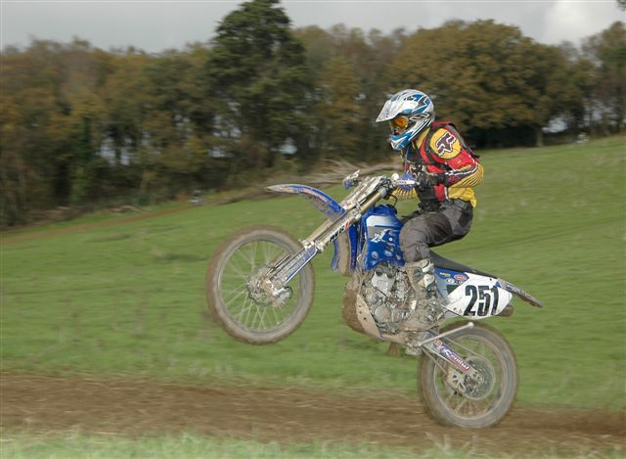
Jamie Fraser Nash (obviously a posh bloke) winning this meetings wheelie competition

In the over 40’s sportsman Paul Corthorn took the first race of series with 9-laps from 2nd place Gary Payne and Mark Robinson also both on 9-laps.

The Sportsman 2-stroke class saw Kevin Pippard take the flag first with fellow 9-laps Stephen Rolls and Simon Allard 2nd and 3rd respectively.

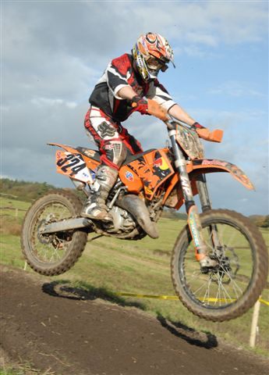
Joe Golding with great air

In the 4-stroke sportsman group Chris Hibbert took all 30-minutes with a 3-minute lead over Joe Shimmin in second with Steve James in 3rd.

The ever popular trail group was won by Lee White with an impressive 9-laps over his closest rival 8-lapper Richard Comben in second and Jim Allwood in third.

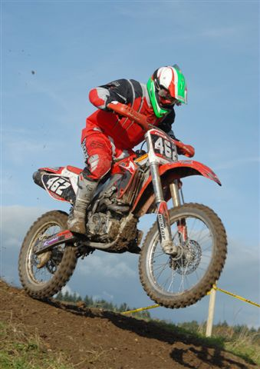
Mark Johnson taking the 4x4 jump

Please note that such is the tendency for people to bring items such as bikes along to sell that Track n Trail will be running Tombola, a guess the weight of the cake stand and jumble stall outside the signing on tent also at the next meeting.

See you all soon

